Tuesday, January11th, 2022

Please see the information and suggested lessons provided below for January11th , 2022.

I sincerely hope that you and your families find yourselves continuing to be active, as much as possible, but most importantly safe and in good health.

Feel free to contact me: cojah@lssd.ca school website: http://mrojah.weebly.com/

Please try the activities below any time during the week! Enjoy and have some fun!

Grades K-2

Please complete our basic stretch routine ~ followed the basic fitness routine or any of the fitness routines found on the main page!

For a fun challenge try one of the “Beat the Teacher ~ Minute to Win It” video challenges found on the main page!

TODAY: Let’s work on some:

** OVERHAND THROWING**

In a safe area of your home or outside.
With a parent/brother/sister or by yourself
**create a TOWER TARGET about 10’ ahead. A couple of empty shoe boxes stacked makes a great target!)**
Use a small ball (one that you can hold in the palm of your throwing hand) or a “Sock Ball.”
Remember to:
Stand feet together – SIDEWAYS to your target.
Ball should start in the palm of your throwing hand – beside your cheek.
Lift your opposite knee ~(opposite your throwing hand)~ so your knee looks at your chin for a moment.
Rotate or turn your body towards your target.
Make sure to step down with your raised leg and foot ~ first to regain proper balance.
Swing throwing arm forward – release ball.
Work hard on your follow through ~ Hand pointing at your target.

Challenge yourself to see how many hits you can make in a ten-minute period.
Or
If possible ~ make two targets, and have a friendly, timed competition with Mom, Dad or Brother or Sister!

Who will be the ultimate champion? Good Luck ~ Have fun!

If possible ~ Have a fun game of 1 vs 1 “THREE LIFE ~ SOCKBALL DODGEBALL” with a partner (Mom/Dad ~ Brother / Sister )
**REMEMBER:
Today, you have a total of 3 lives! Each time your hit today by your opponent ~ you lose a life ~ before restarting your game, you owe your opponent 5 burpees. First to be hit 3 times is out!
Just make sure you in a good area and have permission to play!
Have fun ~ Who will be the Ultimate Sock ball Champion! See how many burpees you can make Mom or Dad do!
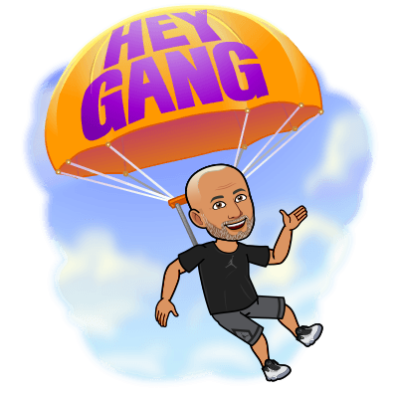

Grades 3-6

Please complete our basic stretch routine ~ followed the basic fitness routine or any of the fitness routines found on the main page!

For a fun challenge try one of the “Beat the Teacher ~ Minute to Win It” video challenges found on the main page!

TODAY: Let’s work on some:

Goaltending skills AND Shooting skills

Using a small soft ball – or (Ball up a couple of pairs of socks) and make a ball.
Find a safe area in your house or outside.
Practice your – Goaltending skills.

**Hopefully, you can work with Mom/Dad ~Brother or Sister for a bit again today!

Create/make a net/target. Today use/make a crease line (painters tape works well)
About 10’ in front of your net/target.

**Today ~ Take turns being the goalie ~ And then have Mom or Dad or Brother or Sister be the goalie and YOU will then become the “SHOOTER/GOAL SCORER”

Have a partner if possible, throw the ball to you, trying to score a goal.

*Remember to have a good balanced stance. Shoulder width apart with your feet.
Knees should be slightly bent, and you should be up, off your heals ~ ready to move quickly to the left or right.

Your ultimate goal is to deflect the ball away from the net or better yet catch and hold on to the ball without creating a rebound.

**REMEMBER TODAY~ IF THE BALL IS COMING AT THE LOWER CORNERS OF THE NET ~ USE YOUR LEGS TO BLOCK AND DEFLECT THE BALL.**

Who will become the Ultimate Goalie? Good Luck.

**If you have time, try out the game found below.
“ THE ROADRUNNER FIDGET SPINNER CHALLENGE!”

“ THE ROADRUNNER FIDGET SPINNER CHALLENGE!”
**Print the following page or just look at the image and follow the exercise listed.
**You will need a “fidget spinner” for this activity!
**To make a Fidget Spinner have the ability to “indicate” an exercise or movement, use a piece of tape cut into a triangle (or arrow shape) to mark one or more of the prongs on a fidget spinner!
Play against a family member ~ Have Fun ~ Good Luck!

